MODULE-1
Classification of Network Elements:

Network elements can be classified into various categories based on their characteristics and functionality. Here's a classification based on the terms you mentioned:
- Active Elements:
Definition: Active elements are devices that require an external source of energy to operate and perform their functions.
Examples:
Amplifiers: They increase the strength or amplitude of signals.
Transmitters: Devices that emit or send signals.
Oscillators: Generate periodic waveforms.
- Passive Elements:
Definition: Passive elements do not require an external source of energy to perform
their functions; they don't amplify or generate signals actively.
Examples:
Resistors: Resist the flow of electric current.
Capacitors: Store and release electrical energy.
Inductors: Store energy in a magnetic field.
3. Linear Elements:
Definition: Linear elements exhibit a linear relationship between cause and effect. In the context of networks, this typically refers to linear circuits that obey the principles of superposition and homogeneity.
Examples:
Resistors: The relationship between voltage and current is linear (Ohm's Law).
Capacitors and Inductors in Linear Circuits: The response is proportional to the input.
4. Non-linear Elements:
Definition: Non-linear elements do not follow a linear relationship between cause and effect. The output is not proportional to the input, and they may exhibit complex behaviors.
Examples:
Diodes: Exhibit non-linear voltage-current characteristics.
Transistors in Non-linear Operating Regions: Outside certain operating conditions, transistors can be highly non-linear.
It's worth noting that these classifications are not mutually exclusive. For example, an element can be both active and non-linear, depending on its operating conditions. Additionally, these classifications are often used in the context of electrical circuits and systems. In the context of networking (such as computer networks), the terms may be used in a different context, referring to devices like routers, switches, cables, etc.

Voltage-Current relations for passive elements
Passive electrical elements are components that do not produce energy but instead consume or store it. The three basic passive elements are resistors, capacitors, and inductors. Here are the voltage-current relations for each of these elements:
V=IR
Capacitor (C):
The current-voltage relationship for a capacitor is given by:
I(t) = C * dV/dt.
This equation relates the current flowing through a capacitor to the rate of change of voltage V across the capacitor. The constant C is the capacitance of the capacitor, measured in Farads (F).
Inductor (L):
The instantaneous voltage drop across an inductor is directly proportional to the rate of change of the current passing through the inductor. The mathematical relationship is given by v = L (di/dt).
This equation relates the voltage V across an inductor to the rate of change of current I flowing through the inductor. The constant L is the inductance of the inductor, measured in Henries (H).
It's important to note that these relations are differential equations for capacitors and inductors, indicating that the current or voltage depends on the rate of change with respect to time. For resistors, the relationship is linear and does not involve differentiation.
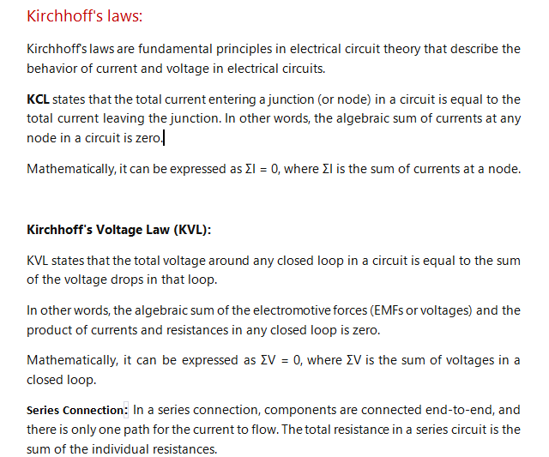.
R_{T}=R₁+ R₂………………………………….R_{n}
The current through each resistor is the same, but the voltage drop across each resistor can be different.
Parallel Connection: In a parallel connection, components are connected at both ends, providing multiple paths for the current. The voltage across each component is the same, but the currents through each branch can differ.

Nodal analysis:
- For the circuit in Fig. 1, obtain v1 and v2.

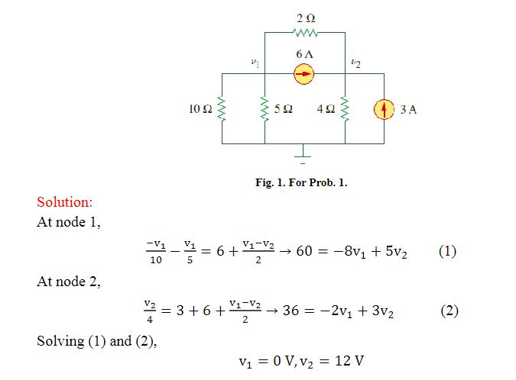

- Apply mesh analysis to the circuit in Fig. 2 and obtain Io.

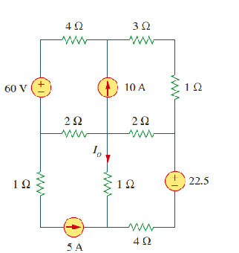
Fig.2
